Title of PAPER (Bold, Upper-Case, Times New Roman, 14 pt Centred)
First A. Author^{1*}, Second B. Author¹, Third C. Author², Fourth C. Author³
¹Department of Mechanical, Aerospace and Civil Engineering, University of Manchester, Manchester M13 9PL, United Kingdom
²Department of Mechanical Engineering, Trinity College Dublin, University of Dublin, Ireland
³Faculty of Science & Engineering, University of Nottingham Ningbo China, Ningbo, China

Abstract
This document provides guidance on the preparation of a paper for UKHTC2021. The abstract heading should be unnumbered and the content should be limited to between 250 and 400 words.
- Recommended Guidelines For Preparing A FULL PAPER
This template has been prepared for authors of full papers to be submitted after acceptance of an extended abstract for the 17th UK Heat Transfer Conference (UKHTC2021) to be held online via the Gather Town platform on 4-6 April 2022. Full papers will be compiled into proceedings and distributed electronically to all participants. Full paper submissions will be expected to conform to this template. For authors who prefer to use LaTeX, a template has been prepared and can be downloaded from the website or the EasyChair submission system.
  - Key Dates
For the most up-to-date information, please see the “important dates” page of our website: http://www.ukhtc2021.org/important-dates.
- Length and formatting of the main text
The length of the full paper may be up to six sides of A4, including figures. Authors will be requested to reduce over-length proposals. The following formatting must be applied:
- Font typeface: Times New Roman
- Font size: Main text – 11pt; Title – 14pt Bold Upper case; Headings – 12pt Bold Upper case for first level, regular case for second level and italicized regular case (without a number) for the third level.
- Spacing: Single-spaced text but leave a single line space (11pt) at the end of each section and paragraph.
- Page format: Single column format, fully justified with 2.5 cm spacing each side of the page and 3.0 cm at the top and bottom.
The correct formatting for each of these elements is available as a “Style”. For convenience, these should be visible in the “Styles bar” on modern versions of Microsoft Word.
A header and footer have been included in this template. The first page header should contain the UKHTC2021 logo aligned left and the conference name and dates aligned right. The first page footer should contain the email address for the corresponding author aligned left. No page numbers should be present on any page, and no header or footer should appear on any subsequent pages.
- Figures
Figures are a vital part of the submission; 4 to 7 figures might be typical. They may appear together at the end or be included within the main text but should be prepared to ensure that they are contained within the paper margins without overlapping text and/or figures. As a general rule, lettering in the figures should be comparable to that in the main text. Colour and black/white photographs are allowed in digital format and should have sufficient resolution to permit high-quality reproduction. Figures should be centred with a line space (11pt) above and below the figure. Figure 1 provides an example.
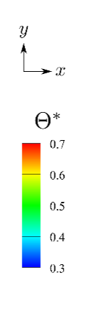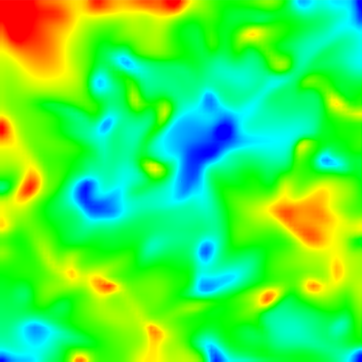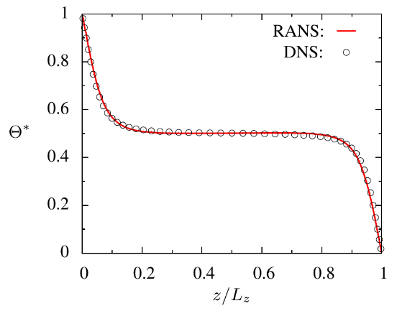
Figure 1: One line figure captions are centred under the figure, with a single line space (11pt) between the figure and the caption and a single line space (11pt) between the caption and the following text. Captions that are two or more lines should be flushed left.
- Tables
Tables should be entered into the document directly as text and should be formatted in Times New Roman. The size of the text within the body can be adjusted accordingly but must not exceed 11pt and must not be smaller than 9pt. Table headings should be centred if one line and left-justified if more than one line. Table 1 provides an example.
Table 1: Parameters of the experimental program.
Parameters | Values
Material | wilted grass, first and second cut
DM/% | 20 - 50
Compaction duration/s | 0.5
Time without compaction/s | 2.5
Number of compaction cycles | 6

- Mathematical Formulae
Mathematical equations should be typed in position with a single line space (11pt) above and below the equation. Equations should not be entered in a non-editable format. The font for the equations should be Cambria Math and the principal size should be 11pt. Subscripts and superscripts should be clearly visible. Equation numbers should be flushed right and aligned with the last line if they span multiple lines. The following table structure can be copied to assist in numbering if needed.
 | $$\frac{∂U_{i}}{∂t}+U_{j}\frac{∂U_{i}}{∂x_{j}}=-\frac{1}{ρ}\frac{∂P}{∂x_{i}}+\frac{∂}{∂x_{j}}\left(ν\frac{∂U_{i}}{∂x_{j}}\right)$$ | (1)
Do not use punctuation at the ends of equations. Align equal signs when equations are stacked with no intervening words. All data should be reported in SI units. Decimals should always be shown by full-stops (periods) and not by commas or centred dots.
- Referencing Style
A numerical referencing style should be used in ascending order of first appearance. Within the text include author names(s) on first mention followed by the reference number in square parentheses; thereafter simply cite a work by its reference number. The references should appear as a numerical list at the end as in the References section below. Journal titles (employing standard abbreviations) should be in italic type. Book titles should also be italicized. Referencing software may be used but please ensure the style is consistent with the examples within this template.
- Conclusions
After you have prepared your full paper, please upload it to your existing submission through the EasyChair Online submission system: https://easychair.org/conferences/?conf=ukhtc2021. After logging in, authors should select the magnifying glass symbol in the “View” column next to the appropriate submission (if more than one). Authors should then add their full paper, by clicking on the “Add or update files” option in the upper right and using the “Browse…” button next to the “Full Paper” entry in the table present.
If you have any questions about the preparation or submission of your full paper please email: ukhtc2021@manchester.ac.uk.

Acknowledgements
Acknowledgements, where appropriate, should be placed immediately following the conclusion section.

References
[1] K. Hanjalić & S. Jakirlić, A model of stress dissipation in second-moment closures. Applied Scentific. Research., 51 (1993) 513–518.
[2] T. J. Craft, A. V. Gerasimov, H. Iacovides, & B. E. Launder, Progress in the generalization of wall-function treatments. Int. J. Heat & Fluid Flow, 23 (2002) 148–160
[3] S. B. Pope, Turbulent flows Cambridge University Press, (2000), Cambridge
[4] T. B. Gatski & C. L. Rumsey, Linear and Nonlinear Eddy Viscosity Models. In B.E. Launder, & N.D. Sandham,eds., Closure Strategies for Turbulent and Transitional Flows Cambridge University Press, (2002), pp. 9–46, Cambridge
[5] D. R. Wilson, T. J. Craft, & H. Iacovides, On the development of URANS turbulence closure models: Flows subjected to electromagnetic and other body forces. Proc. 10th Int. Symp. on Engineering Turbulence Modelling and Measurements, Marbella, Spain, (2014).

